## Modeling of motor

# Define parameters for motor sampling

**Test with L298N motor driver**

We examine the linear relation between the input $(\%PWM)$ and the output revolution of the motor’s shaft $(rpm)$. To do that, we $PWM$ signal is fed into the motor, duty cycle from $5-100\%$. After that, we read the $rpm$ signal from the encoder.

Table 4.1. Table of rpm data of motor

|  |  |
| --- | --- |
| **%PMW** | **rpm** |
| 5% | 0 |
| 10% | 0 |
| 15% | 28.133 |
| 20% | 50.7385 |
| 25% | 69.346 |
| 30% | 85.8935 |
| 35% | 104.143 |
| 40% | 118.375 |
| 45% | 129.678 |
| 50% | 141.245 |
| 55% | 151.046 |
| 60% | 161.361 |
| 65% | 168.31 |
| 70% | 176.172 |
| 75% | 181.71 |
| 80% | 187.617 |
| 85% | 192.982 |
| 90% | 198.063 |
| 95% | 202.461 |
| 100% | 219.046 |

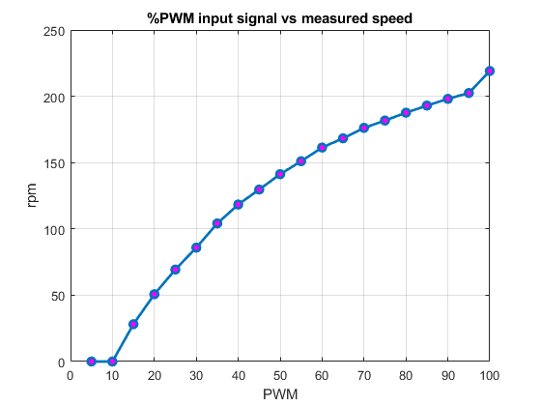

Fig 4.2. %PWM vs measured velocity (rpm) graph

**Test with TB6612 motor driver**

Follow the same procedure as above:

Table 4.2. Table of rpm data of motor

|  |  |
| --- | --- |
| **%PMW** | **rpm** |
| 5% | 0 |
| 10% | 21.4281 |
| 15% | 33.0784 |
| 20% | 45.6978 |
| 25% | 59.2714 |
| 30% | 71.612 |
| 35% | 85.1655 |
| 40% | 98.9197 |
| 45% | 111.3331 |
| 50% | 123.494 |
| 55% | 136.1053 |
| 60% | 149.1838 |
| 65% | 162.2477 |
| 70% | 176.4101 |
| 75% | 187.6647 |
| 80% | 198.401 |
| 85% | 214.4792 |
| 90% | 229.4622 |
| 95% | 241.7738 |
| 100% | 254.8411 |

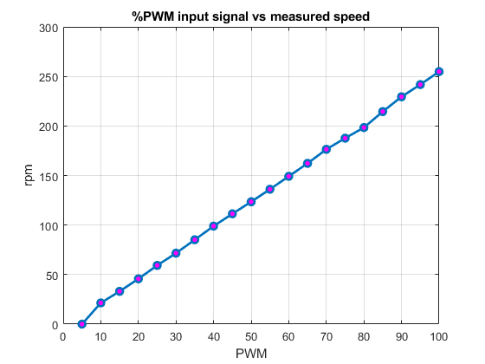

Fig 4.3. %PWM vs measured velocity (rpm) graph

We see that the TB6612 helps making the relationship between PWM and speed linear better than L298N.

# Determine motor transfer function

Prepare data for SIT

Let a PWM input changes in the function $f\left(t\right)=127.5\sin{(t)}+127.5$

$$→T=6.28(s)$$

Then:

$$N×δt=m×T$$

$δt$ is from the Nyquist criterion

$$f_{Sampling}≥2f_{signal}→δt≤\frac{1}{2}T$$

Our $T$ satisfy the condition.

$$→N×0.022=m×6.2832$$

We choose $N=1428; m=5$ (must be integer)

For the motor, the output signal is the revolution of the output shaft $(rpm)$, input is $PWM$ in a sinusoidal wave. So in order to obtain the motor transfer function, we will provide the motor with $\%PWM$, then measure the revolution of the output shaft.

* Plotting the input and output data. We obtain the following graph:

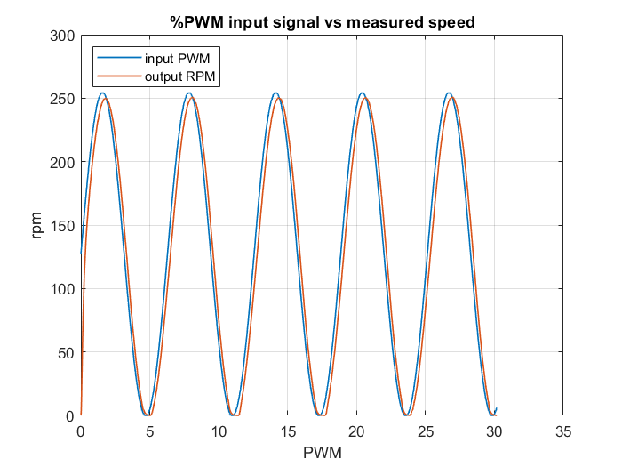

Fig 4.3. Measured speed of the motor

* Using MATLAB System Identification Toolbox (SIT), we yield the following transfer function of the motor-driver plant 1

$$G\left(s\right)=\frac{1.008}{0.18162×s+1}= \frac{5.55}{s+5.51}$$

|  |  |
| --- | --- |
|  | Current value |
| Settling time | $$T_{s}=0.18162×4=0.72648 (s)$$ |
| Overshoot | $$1\%$$ |
| Steady-state error for step input | $$0.01$$ |

Validation of transfer function

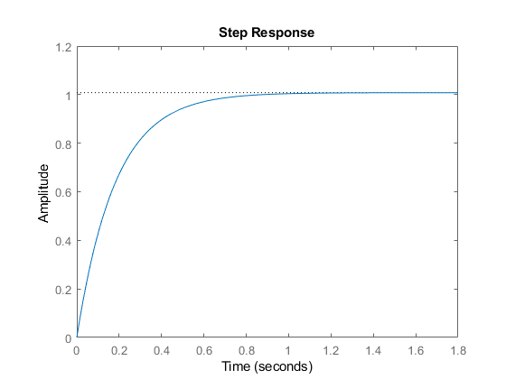

Fig 4.4. Step response graph of the transfer function

**PID Control Design**

When we add a controller, the closed loop transfer function will change, so we have to test to make sure it is accurate in real life. Assume negative unity feedback.

Validation of transfer function

Check Steady state error for step input:

$$\lim_{s→0}\frac{1}{1+\frac{5.55}{s+5.51}}=0.5$$

Test by real data plot:

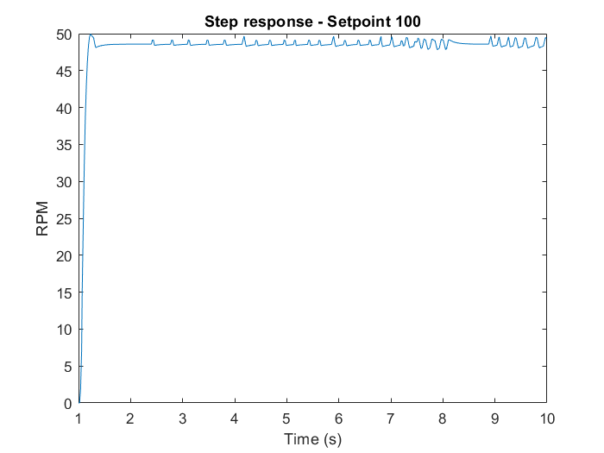

We want to make the motor-driver settling time smaller than the sampling time of the microcontroller so that it can work fine. $T_{s}<δt$

Select $T_{s}=0.015 s→\frac{0.72648}{0.015}=48$ times faster than original

Keep the overshoot at this moment. We also want to remove steady-state error for step input

With the above requirements, we implement the PID controller for this motor-driver plant. Assuming negative unity feedback, the forward transfer function will be

$$K\frac{\left(s+a_{1}\right)\left(s+a_{2}\right)}{s}×\frac{5.55}{s+5.51}$$

$$ζ=-\frac{\ln\left(\%OS\right)}{\sqrt{{\ln\left(\%OS\right)}^{2}+π^{2}}}=-\frac{\ln\left(0.01\right)}{\sqrt{{\ln\left(0.01\right)}^{2}+π^{2}}}=0.8261$$

$$T_{s}=0.015=\frac{-\ln\left(0.02\sqrt{1-ζ^{2}}\right)}{ζω_{n}}→ω_{n}=\frac{-\ln\left(0.02\sqrt{1-{0.8261}^{2}}\right)}{0.015×0.8261}=361.991$$

Then the PID controller:

$$\frac{K\left(s+a_{1}\right)\left(s+a_{2}\right)}{s}$$

Select $a_{2}=0.001$

Desired characteristics equation:

$$1+\frac{K\left(s+a_{1}\right)\left(s+a_{2}\right)}{s}\frac{5.55}{s+5.51}=0→s^{2}+5.51s+5.55×\left[Ks^{2}+K\left(a_{1}+a_{2}\right)s+Ka_{1}a_{2}\right]=0$$

$$→\left(5.55K+1\right)s^{2}+[5.51+5.55K\left(a_{1}+a_{2}\right)]s+5.55Ka_{1}a_{2}=0$$

Desired characteristics equation form: $s^{2}+2ζω_{n}s+ω_{n}^{2}=0$

$$→\left\{\begin{aligned}ω_{n}=\sqrt{\frac{5.55K{a_{1}a}_{2}}{5.55K+1}}=361.991→\sqrt{\frac{0.00555Ka_{1}}{5.55K+1}}=361.991 \\ ζ=\frac{5.51+5.55K\left(a_{1}+a_{2}\right)}{2ω_{n}\left(5.55K+1\right)}=\frac{5.51+5.55Ka_{1}+0.00555K}{2×361.991×\left(5.55K+1\right)}=0.8261\end{aligned}→\left\{\begin{aligned}K=\frac{1}{5.55} \\ a_{1}=592.5738\end{aligned}\right.\right.$$

PD (by settling time)

Desired characteristics equation:

$$1+K\left(s+a_{1}\right)\frac{5.55}{s+5.51}=0→s+5.51+5.55×Ks+5.55×Ka_{1}=0$$

$$→s=-\frac{5.51+5.55Ka_{1}}{5.55K+1}=48×\left(-5.51\right)=-264.48=s_{0}$$

Select $a_{1}=132.24$

$$K=\frac{1}{\left|T\left(s_{0}\right)\right|}=0.3528$$

$$0.3528(s+132.24)×\frac{5.55}{s+5.51}$$

PI

Desired characteristics equation:

$$1+\frac{K\left(s+a_{2}\right)}{s}\frac{5.55}{s+5.51}=0→s^{2}+5.51s+5.55×Ks+5.55×Ka_{2}=0$$

$$a_{2}=220$$

$$K=106$$